Group 09

========================= 27/10, Sprint 1 =========================

**Scrum meeting 2**

Time: 07:30 - 09h30 27/10/2021

| No | Team member | ID | Join at | Left at | Absent | Late | Note |
| --- | --- | --- | --- | --- | --- | --- | --- |
| 1 | Nguyễn Văn Tiến | 19125124 | 07:20 | 09:30 |  |  |  |
| 2 | Nguyen Minh Thu | 18125146 | 08:01 | 09:30 |  | x |  |
| 3 | Mai Thị Cẩm Vân | 19125130 | 07:36 | 09:30 |  | x |  |
| 4 | Tạ Ngọc Minh Khoa | 19125100 | 07:26 | 09:30 |  |  |  |
| 5 | Thái Ngọc Thành Đạt | 19125083 | 07:29 | 09:30 |  |  |  |

Content

| Timeline |  |
| --- | --- |
| 07:40 | Review 2.1 Vision Document  There are 3 account : admin ,owner, user  Owner -> has information of the restaurant  User: status or review -> tagged the restaurant, review the restaurant, vote the restaurant : up vote/down vote  Do we need an owner account???  Main purpose of the project: social network about food.  Like facebook food groups in miniature. |
| 08:15 | Review 2.2 Vision Document  Similar to 2.1 but described in a different way |
| 08:23 | Review 3.1 Vision Document |
| 08:25 | Review 3.2 Vision Document  Teenager and Family group into Regular user |
| 08:30 | Review 3.3 Vision Document |
| 08:43 | Review 3.4 Vision Document  Write more about competition. |
| 08:50 | Review 4 Vision Document  Need more specific description about feature |
| 08:57 | Review 5 Vision Document  High-level: cái nhìn tổng thể, đơn giản nhất về 1 cái feature |
| 09:08 | Review revised 2.1 Project Plan |
| 09:10 | Review revised 2.2 Project Plan |
| 09:12 | Review revised 4.2.1 Project Plan |

Status report:

* Nguyễn Văn Tiến:
  + Complete tasks
    - Complete parts 3.1 and 3.2 in the Vision Document
  + To-do tasks
    - Update parts 3.1 and 3.2 in the Vision Document
  + Issue/Obstacles
    - Unclear about stakeholder and user.
* Thái Ngọc Thành Đạt
  + Complete tasks
    - Parts 4.1,4.2 and 5 in the Vision Document
  + To-do tasks
    - Add more non-functional requirements
  + Issue/Obstacles
* Tạ Ngọc Minh Khoa
  + Complete tasks
    - Parts 3.1 and 3.2 in the Vision Document
  + To-do tasks
    - Rewrite parts 3.3, 3.4 in Vision Document
  + Issue/Obstacles
    - Unclear about task cycle, people involved in user environment
* Mai Thị Cẩm Vân
  + Complete tasks
    - Complete parts 2.1,2.2 in the Software Vision Document
    - Complete parts 4.2.1 in the Project Plan
  + To-do tasks
    - Read and review two links: [Vision document - IBM Documentation](https://www.ibm.com/docs/en/elm/7.0.1?topic=requirements-vision-document), [Course Registration (uhcl.edu)](https://sce.uhcl.edu/helm/RUP_course_example/courseregistrationproject/).
    - Revise parts 2.2 in Vision Document3
  + Issue/Obstacles
    - Unclear about owner account.
    - Unclear about website structure, flow.
    - Estimate release plan in 4.2
* Nguyễn Minh Thư
  + Complete tasks
  + To-do tasks
    - Parts 1 Vision Documents
    - Parts 4.2.3 Software Project Plan
  + Issue/Obstacles

Screenshot:

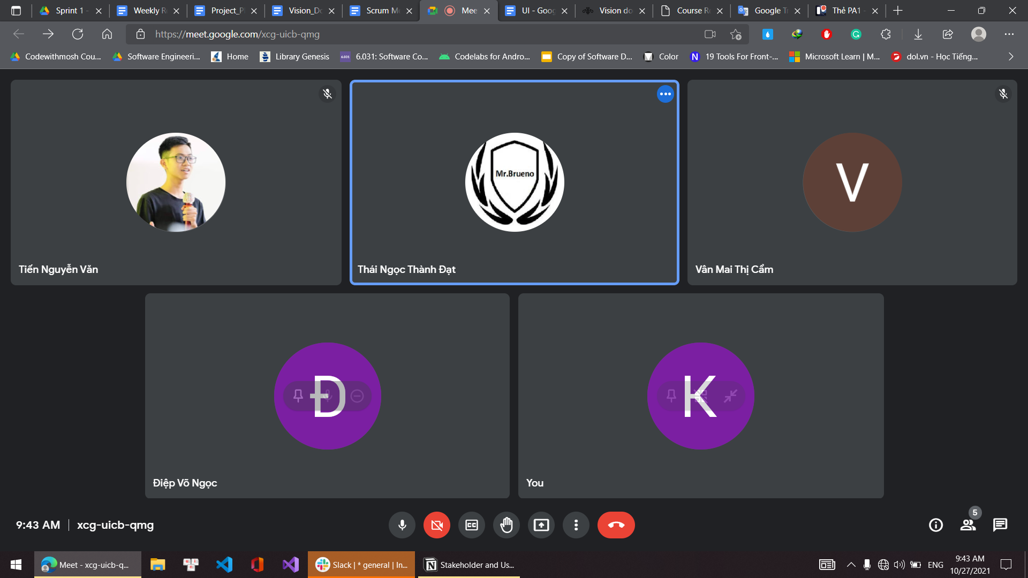

========================= 22/10, Sprint 1 =========================

**Scrum meeting 1**

Time: 20:00 - 21:40 22/10/2021

| No | Team member | ID | Join at | Left at | Absent | Late | Note |
| --- | --- | --- | --- | --- | --- | --- | --- |
| 1 | Nguyễn Văn Tiến | 19125124 | 20:01 | 21:41 |  |  |  |
| 2 | Nguyen Minh Thu | 18125146 | 20:00 | 21:40 |  |  |  |
| 3 | Mai Thị Cẩm Vân | 19125130 | 19:57 | 21:40 |  |  |  |
| 4 | Tạ Ngọc Minh Khoa | 19125100 | 20:00 | 21:40 |  |  |  |
| 5 | Thái Ngọc Thành Đạt | 19125083 | 20:01 | 21:40 |  |  |  |

Content

| Timeline |  |
| --- | --- |
| 20:00 | Review introduction → no amendment |
| 20:20 | Review 2.1 → Fix project purpose + Define scope/objectives |
| 20:26 | Review 2.2 → some are good but some still need to be fixed. |
| 20:35 | Review 3 |
| 20:45 | Review 4 |
| 21:10 | Notes:  Tien: Diagram, %  Van Mai: review her parts/objectives  Dat: Add objectives, scope and some more |
| 21:14 | Discuss 4.2.1 |
| 21:22 | Review 4.2.3 |
| 21:27 | Discuss 2.3 |
| 21:30 | Vision Document:  Minh Thu: Introduction  Van Mai: 2  Dat: 4 5  Khoa: 3.3 3.4 |
| 21:40 | Switch task from done to doing in Trello  Check Slack mess + finish tasks on time |

Status report:

* Nguyễn Văn Tiến:
  + Complete tasks
    - Complete part 3 in the Software project plan
  + To-do tasks
    - Part 2.3 in the Software project plan
    - Writing weekly report 1 for Sprint 1
    - Set up tasks for each member in Trello
  + Issue/Obstacles
    - Unclear some role in project organization
    - Unclear Google Drive folder structure
* Thái Ngọc Thành Đạt
  + Complete tasks
    - Write brief parts 2.1 and 2.2 in the Software project plan
  + To-do tasks
    - Review again and complete parts 2.1 and 2.2 in the Software project plan
    - Parts 4, 5 in the Vision document
  + Issue/Obstacles
    - Minor mistake in defining project scope and objectives which had no actual impact.
* Tạ Ngọc Minh Khoa
  + Complete tasks
    - Complete parts 4.3.1 and 4.3.3 in the Software project plan
  + To-do tasks
    - Parts 3.3 and 3.4 in the Vision document
    - Prepare note for scrum meeting 2 in Sprint 1
  + Issue/Obstacles
* Mai Thị Cẩm Vân
  + Complete tasks
    - Write brief parts 4.2.1 and 4.2.2 in the Software project plan
  + To-do tasks
    - Review and complete parts 4.2.1 and 4.2.2 in the Software project plan
    - Part 2 in the Vision document
    - UI training
  + Issue/Obstacles
    - The confusion about the description of PA1 and the lack of lecture note 4 leads resulted in the Iteration Plan section not being completed.
* Nguyễn Minh Thư
  + Complete tasks
    - Complete part 1 in the Software project plan
    - Write brief part 4.2.3 in the Software project plan
    - Writing notes for sprint planning and scrum meeting 1 in Sprint 1
  + To-do tasks
    - Part 1 in the Vision document
    - Review and complete part 4.2.3 in the Software project plan
  + Issue/Obstacles

Screenshot:

